PeopleSoft FMS
High-level Design
Change ID: PTPS-677- Attachment & BU related issue in Voucher Approval AF page

High-Level Design

Document ID | PTPS-677
Version | 0.1
Version Date | 22/10/2020
Company

Table of Contents
1. Document Control 4
1.1 Version History 4
1.2 Approval 4
1.2.1 Review(s) 4
1.2.2 Approval(s) 4
1.2.3 Deviations from Mandatory Approvers 4
2. Introduction 6
2.1 Purpose 6
2.2 References 6
2.3 Definitions and Acronyms 6
3. Design overview 6
3.1 Design Scope 6
3.1.1 In Scope 6
3.1.2 Out of Scope 6
3.2 Functional Overview 6
3.3 Summary of Impacted Components 6
3.3.1 Applications 6
3.3.2 Databases 6
3.3.3 Interfaces 7
3.3.4 Documentation 7
3.4 Design Considerations and Constraints 7
3.5 Conventions and Standards Followed 7
3.6 Design Issues and Risks 7
3.7 Development Environment 7
3.8 Testing 7
3.8.1 Testing Considerations 7
3.8.2 Technical Only Considerations 7
3.9 Assumptions and Dependencies 7
3.9.1 Assumptions 7
3.9.2 Dependencies 7
4. High Level Design 7
4.1 Solution Design 7
4.1.1 System Technical Flow 17
4.1.2 Technical Design 17
4.1.3 Security Design 17
4.1.4 Implementation Approach 17
4.1.5 Backup and restoration considerations 17
4.2 High Level Data Design 17
4.2.1 High level Database Design 17
4.2.2 Logical Table / File Layouts 17
4.2.3 Data conversion / migration 17
4.3 High Level Interface Design 17
4.3.1 User interfaces 17
4.3.2 System interfaces 17
4.4 Design Alternatives Considered 17
4.5 Errors & Exception Handling 17
Appendix A: Screen Layouts 18
Appendix B: Report Layouts 19

Document Control

Version History
Version | Date | Change Description (include list of reviewers) | Author
0.1 | 10/22/2020 | 1st draft | Nazeer Shaik

Approval
{Refer to Process Bank work product WDES001 for information on recommended reviewers and mandatory approvers}

Review(s)
Title | Name | Delegate  (Y/N)* | Approval Reference  (e.g., email) | Date | Version Approved
Attachment & BU issue in Voucher Approval AF page | Nikhil Kulkarni

Approval(s)
Document versions are approved by the following people:
Title | Name | Delegate  (Y/N)* | Approval Reference  (e.g., email) | Date | Version Approved
Attachment & BU issue in Voucher Approval AF page | Nikhil Kulkarni
* If Delegate is marked as ‘Y’, the details of delegation should be mentioned in section 1.2.3

Deviations from Mandatory Approvers
The reason for delegation of approval rights (if any) is shown below:
Name of Delegate | Reason for delegation from mandatory approval(s)

Introduction

Purpose
Business user unable to access the vouchers Approval AF page also attachment related page due to security restriction.
References
Document | Description
PTPS-677 | Attachment & BU issue in Voucher Approval AF page

Definitions and Acronyms
In this document:

Design overview

Design Scope

In Scope
Incorporate IRN number & IRN date and HSN code on voucher page in AP module for India tax E-Invoicing.

Out of Scope
This requirement is not applicable to any business unit other than India.

Functional Overview
1.Business user unable to open the vouchers Approval AF page due to business unit security issue.
2. Attachment related component access not able access due to attachment component is not enabled at security level.
User are excepting to access the vouchers Approval AF page and attachment related page.

Summary of Impacted Components

Applications
FMS V9.2 Global instance
FMS V9.2 NZ Standby instance

Databases

Interfaces

Documentation

Design Considerations and Constraints

Conventions and Standards Followed

Design Issues and Risks
Not applicable

Development Environment
PS V9.2

Testing

Testing Considerations

Technical Only Considerations

Assumptions and Dependencies

Assumptions
After development changes users able to access Voucher Approval AF page
With all Business unit without any user security related issues.
Also user able to access the attachment related page without any user security related issues.

Dependencies

High Level Design

Solution Design
- Creating new view ANZ_AP_CREDT_VW and assigned this view as prompt table for a business unit field in Voucher Approval AF page and Component level search record BU field.

Below are the details about the new View
New View name: ANZ_AP_CREDT_VW

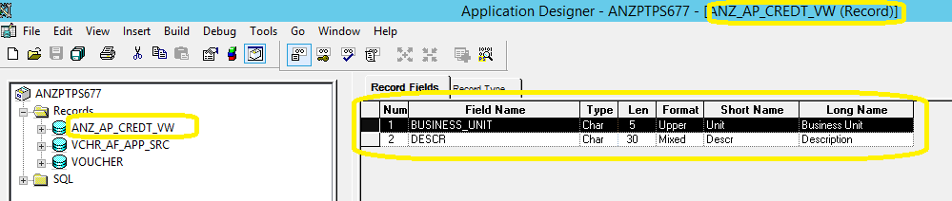

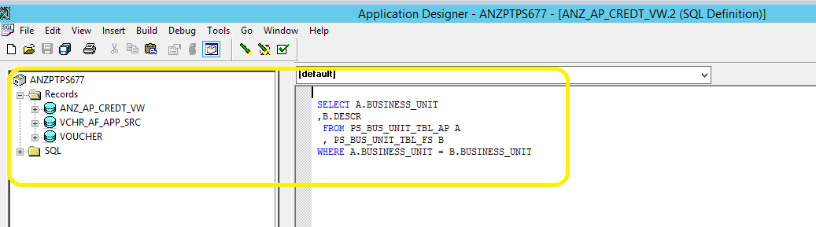
Existing prompt table view is SP_BUS_AP_CLSVW and replaced with new view ANZ_AP_CREDT_VW to avoid the user security in Voucher Record
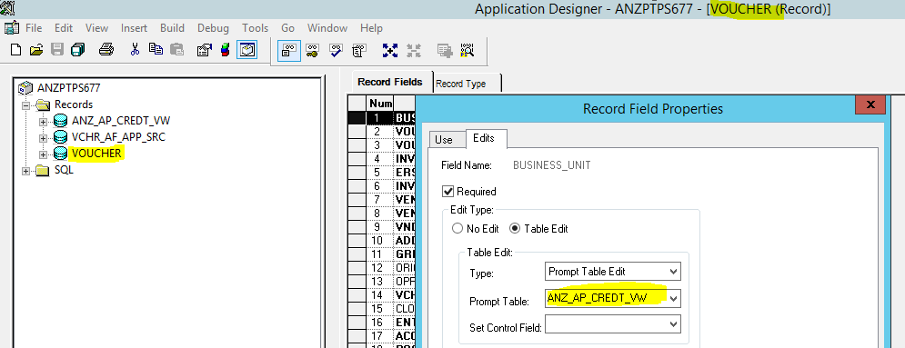

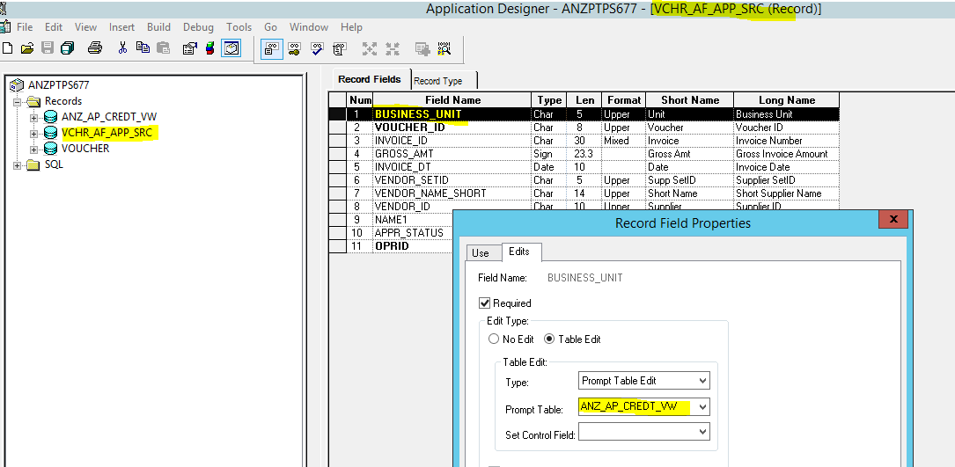

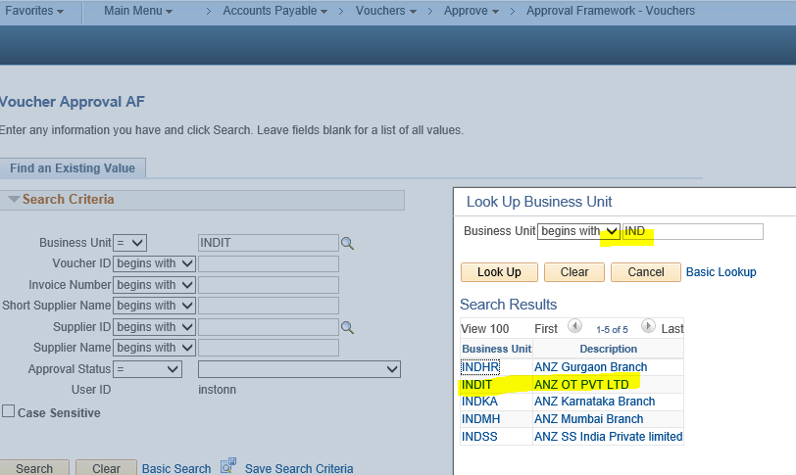

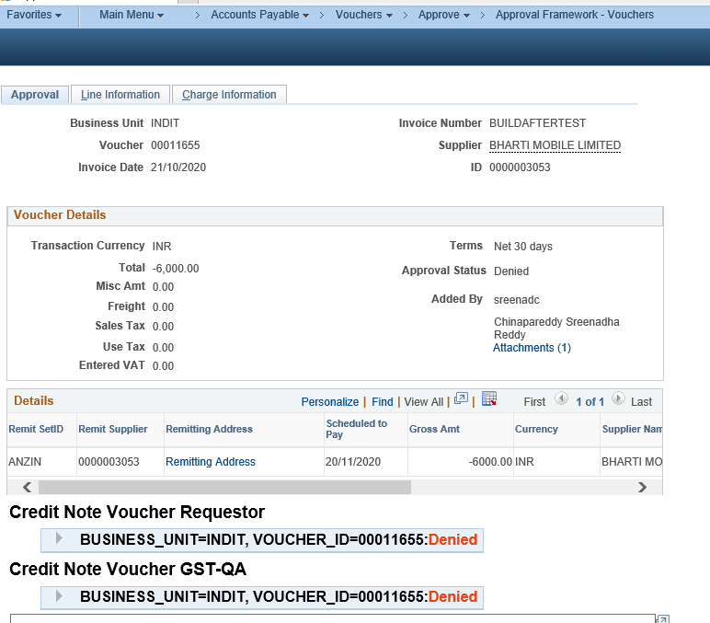

The Attachment functionality component is VCHR_ATTACHMENT, where the component permissions is not enabled under existing Permission list AP000036 . Enabled the access to the component and now able to access the attachment page for business user(instonn)

Enabled the component VCHR_ATTACHMENT in existing Permission list AP000036 to get Voucher attachment related page access to the business users

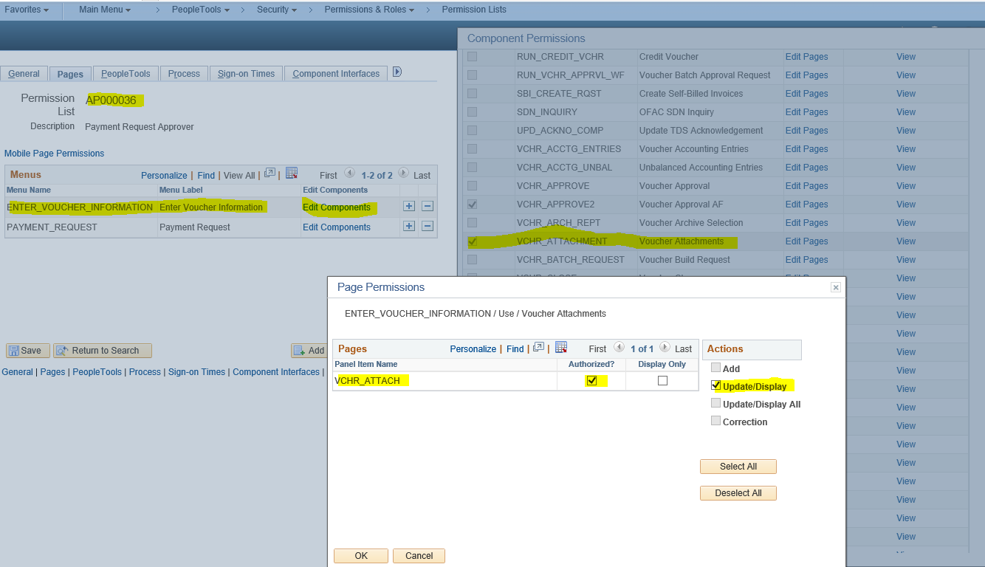

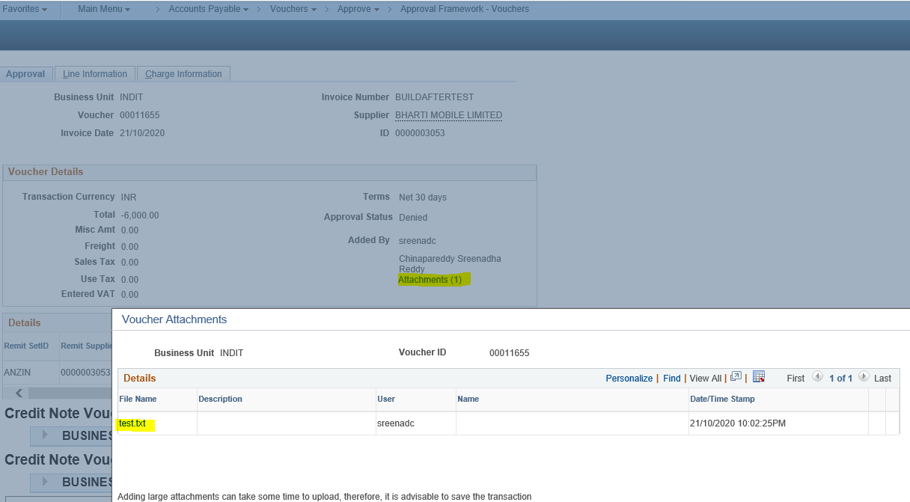

Field Mapping

Name of Record | Field Name | Record Field Name
Voucher | BUSINESS_UNIT | Voucher(ANZ_AP_CREDT_VW)
VCHR_AF_APP_SRC | BUSINESS_UNIT | VCHR_AF_APP_SRC (ANZ_AP_CREDT_VW)

Testing considerations

- User has to verify the Voucher Approval AF page with all Business unit without any user security related issues
- User should be access the attachment related page without any user security related issues

System Technical Flow
n/a

Technical Design
n/a

Security Design
Existing security applied

Implementation Approach

Backup and restoration considerations

High Level Data Design

High level Database Design

Logical Table / File Layouts

Data conversion / migration

High Level Interface Design

User interfaces

Screen Hierarchy and Navigation

System interfaces

Design Alternatives Considered

Errors & Exception Handling

- Screen Layouts
{Delete this section if not applicable}

- Report Layouts
{Delete this section if not applicable}

